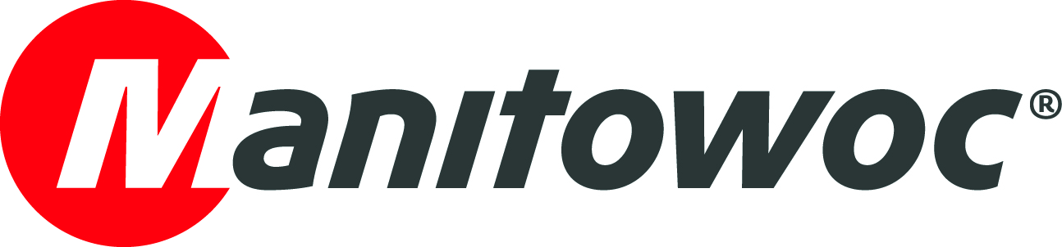
CAPTION RELEASE

December 12, 2018

Two new GMKs sold to HTC WOLFFKRAN

UK-based crane supplier HTC WOLFFKRAN has recently taken delivery of a brand-new GMK6300L-1; its second Grove all-terrain crane of 2018. The crane joins the company’s GMK5250L, which was purchased earlier this year and displayed at Vertikal Days 2018.

The 300 t (350USt) capacity GMK6300L-1 features a maximum tip height of 120 m (394 ft) when working with its full 80 m (263 ft) main boom and 37 m (121 ft) of jib. When lifting with the main boom, it can lift up to 14 t (15.4 USt) at full height and can handle this within a 15 m - 28 m (50 ft – 90 ft) working radius, offering a flexible range for such applications as tower crane rigging.

“We’re extremely happy with both of our Grove purchases this year,” says Dave Holder, managing director of HTC WOLFFKRAN. “WOLFFKRAN prides itself on setting standards in technology and service, and Grove cranes help us to provide for our customers every need.”

-END-

CONTACT
Insa Heim
Marketing Communication Manager, Manitowoc Crane Group Germany
T +49 4421 294 4170
insa.heim@manitowoc.com

ABOUT THE MANITOWOC COMPANY, INC.
Founded in 1902, The Manitowoc Company, Inc. is a leading global manufacturer of cranes and lifting solutions with manufacturing, distribution, and service facilities in 20 countries. In the United States, the Grove, Manitowoc, National Crane, Potain and Shuttlelift brands are sold and serviced by Grove US, LLC, a wholly owned subsidiary of The Manitowoc Company, Inc. In 2017, Manitowoc’s net sales totaled $1.6 billion, with over half generated outside the United States.

THE MANITOWOC COMPANY, INC.
One Park Plaza – 11270 West Park Place – Suite 1000 – Milwaukee, WI 53224, USA
T +1 414 760 4600
www.manitowoc.com

